Additional file 2
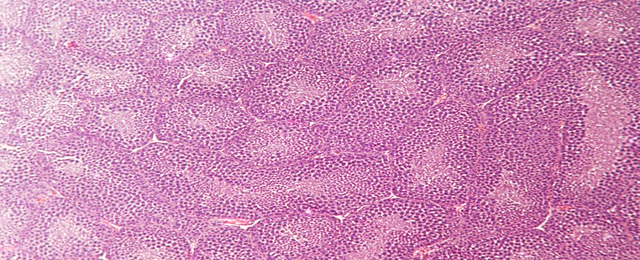
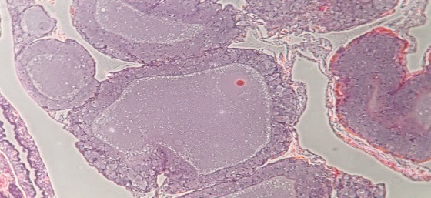
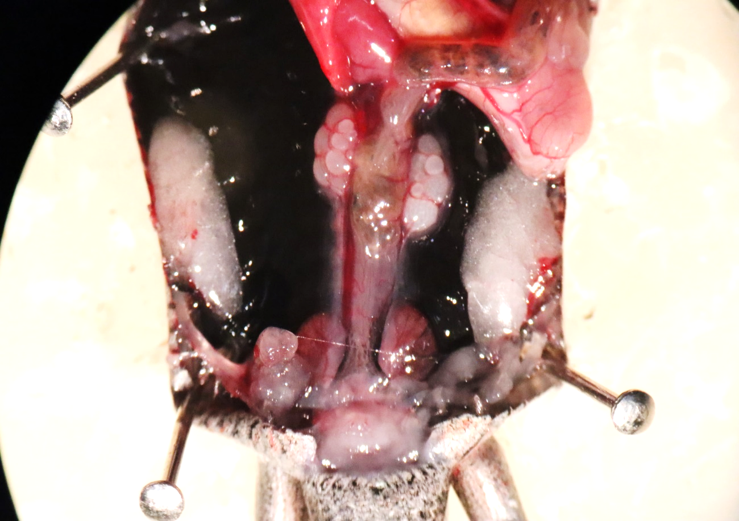
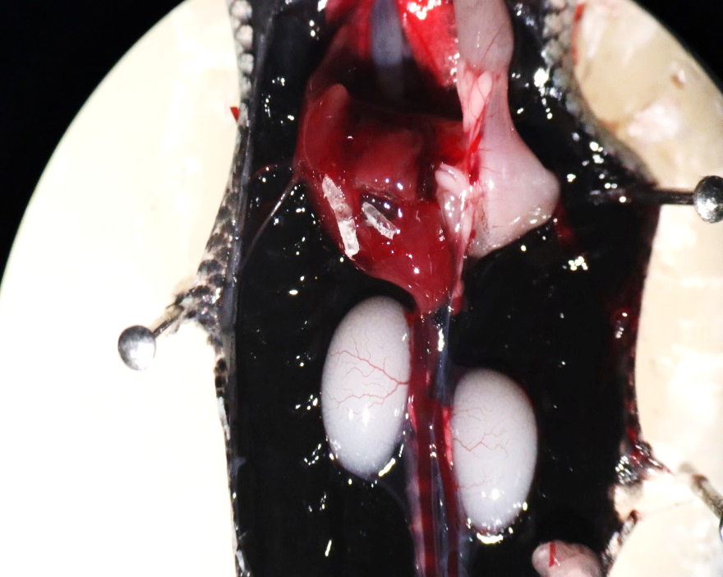
Figure S1: A: View of gonads a) Ovary b) testis in adult male individuals B) Histological sections of gonads: c) Ovary and d) testis
a
b
c
d
A
B

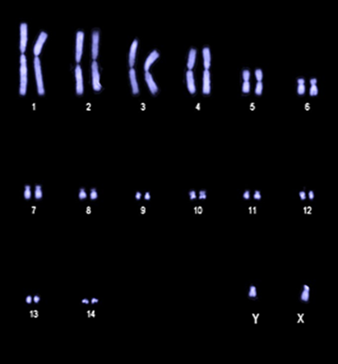
Figure S2: Karyotypes of male scincid lizards B. duperreyi

